OOP Assessment Stage 9

For this stage you should add the following function to your system-
- Updating the available Stock Level of each product bought within an OrderLine

- Updating Stock Level of Products

This function is for Customers and is run via ‘’Buy” on the Basket form.
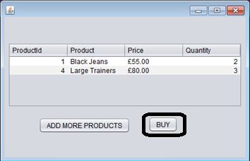

You should create a DBManager method for modifying the Stock Level of a product. This method will have 2 input parameters: productId (int) and quantity (int).
This method will update the Product with the given productId (from the input parameter) by subtracting the quantity (from the other input parameter) from the Stock Level, using the formula: StockLevel = (StockLevel - Quantity), or another similar method (you may do it differently if you wish).
You should then make a call to this DBManager method within your loop for-each-OrderLine ensuring you pass in the productId and quantity parameters (2 parameters) from your orderLine.
You should then test this fully works as well by ensuring that it subtracts from the database the quantity you ordered for each product, and also that when the quantity has been reduced on the database that you cannot then purchase more than this from the shop.
To Help With Updating Stock Level-
You can use the following design for updating the stock level appropriately (in your DBManager class)-
public void updateStockLevel(int productId, int quantity)
{
try
{
// Setup your drivers, connection and statement
stmt.executeUpdate("UPDATE Products SET StockLevel = (StockLevel - " + quantity + ") WHERE ProductId = " + productId);
}
catch(Exception ex)
{
// Display error message
}
}

